
Year 9 - 2015

Investigation 1

Semester One Term 1

Probability

This investigation has three sections. Section 1 will be completed in class as a group. Section 2 is to be completed at home and Section 3 will be completed in class under test conditions. For Sections 1 and 2 you are allowed to ask for help and guidance, however, Section 3 will be completed under test conditions to fully test your understanding. No guidance or hints will be provided.

AIM: In this assessment you will be investigating probabilities of two step events, calculating relative frequencies both with and without replacement. This will be done using both diagrams and calculations.

Section 3

Name: ______________________________________________ Class: __________________ Mark: /18

You have a bag which contains 4 coloured balls: two red, one blue and one yellow.
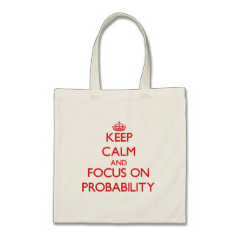
Yellow
Blue
Red
Red

You choose a ball at random from the bag without replacement. You then choose a second ball and record your outcome.

- If you were to try this experiment, how many times would you need to complete it to make it valid? Why?
(2 marks)

- Draw a tree diagram to show the theoretical probability for each possible choice combination.
(5 marks)

- Using your tree diagram, find the following probabilities:
(5 marks)

- Pr (red and blue in any order)

- Pr (yellow then red)

- Pr (not yellow)

- Pr (not red)

- Pr (yellow or blue on first choice)

- Consider the following frequency table. Is there a difference between the experimental probability (relative frequency) and theoretical probability for this sample space? Why?
(6 marks)

Spinner 1 Spinner 2
White
Yellow
Yellow
Blue
Blue
Red
Red
Red

Spinner 1 | Spinner 2 | Frequency | Relative Frequency
Red | Red | 2
Red | Blue | 5
Red | Yellow | 1
Blue | Red | 3
Blue | Blue | 2
Blue | Yellow | 4
Yellow | Red | 0
Yellow | Blue | 1
Yellow | Yellow | 3
White | Red | 2
White | Blue | 4
White | Yellow | 3

Hint: Use this space to calculate the theoretical probability for this sample space.

THIS PAGE HAS BEEN LEFT BLANK INTENTIONALLY

